# W3P Online Webinar/ Demo

**7.30 pm 24 September 2013**

Hosted by Ashley Moore and Gavin of w3P UK.

The W3P solution consists of three components

1. MIS (Back End)
2. B2B (Corporate Business Portals)
3. B2C (General customer storefront that can be linked to your existing website URL)

**1. The MIS**

Import existing and create new accounts

Import all your products, allocate codes and use these for quotes

When manually producing a quote you can add extra charges such as design fees and carrier charges.

Can print or email quotes, create the job from the quote

For offline jobs the PDF’s are approved by email, when the artwork is approved the job number is added to the file name and it is loaded into the system; the system searches for the job numbers and associates it automatically to the job.

Jobs can be sorted using a workgroup summary, so each morning the day’s work can be easily identified and jobs can be tracked on the system this way. Jobs are categorised by status codes e.g. 00 Speculative jobs (May not progress), 11 Proofed online, 81 released for production.

Set the bleed etc. when setting up for production, you can tell the system that you want the cut marks on the PDF for production and the system will add them when the status is changed to 81 (ready for production).

Build Portals, microsites or a public site linked to your own website easily in the MIS, easily add to them with “Create a new page”.

CSV into Excel

Filter and export to Mail Chimp

**2.B2B Corporate Portals**

Revive – demo site

Each customer has individual logins, can set access levels so management approve orders. The Management tab is only available to Administrator logins.

Templates are designed using InDesign, upload using the W3P software and can create an editable template, easy to designer can easily create a template. Zones can locked or set as editable to meet the corporate requirements. You can make a template more flexible letting the customer chose the font and colour etc.

When placing orders the customer can select the turnaround time, these can be pre-set with the product.

If the customer is ordering from a template then you can also add discount vouchers to the template - effectively giving them a personal discount.

When placing the order the customer can give it a title to help them recognise the job in the future (doesn’t show image icons like OnPrinShop).

The customer is given a reference number to track the job.

The corporate site has a Files and Images Store that can be used by the company to share any correspondence with the print company or any company images etc available for logged in staff to use.

Corporations can add their own users as well as Copy Express.

All products are linked to the MIS

You can set up a portal for small similar companies (referred to as microsites or private shops) that are not large enough to warrant their own individual one. Several (as many as you wish) customer can access the same portal but will not see each other’s orders etc. You can assign templates to particular customers; this is good for similar type customers such as hairdressers as the layout would be the same for each, just the content offered would be different. Products can be priced to particular customer; this requires them to be stored in the MIS under different product numbers.

**3.B2C Store Front**

You can link this to your existing website URL, and you can easily build the site via your MIS system. You can use the plugin for the Template Cloud Library which has 20000 designs via Fotolia.com. You can add your own designs which will then become available worldwide and you will be rewarded royalties when they are used.

Linked to the MIS

Payment online

Fully Editable designs are available.

Example site: <http://www.flyerzone.co.uk/>

**The Pricing Schedule**

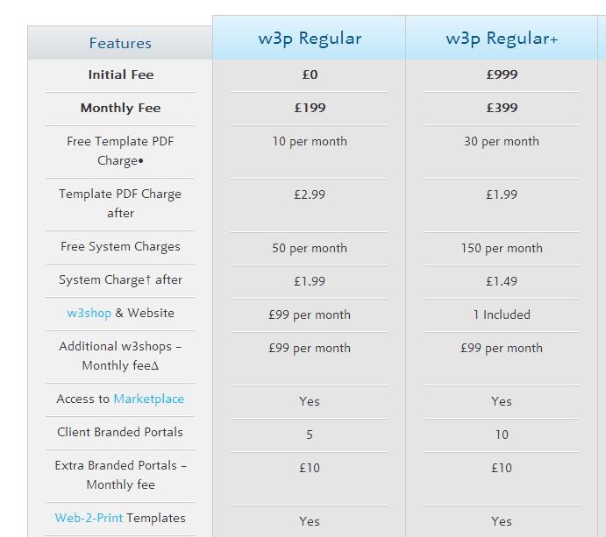

The First 50 orders are free and then charge of 1.99 pounds per order

*The 1.99 system charge is applied every time the system is used to process an order using the In-House or OpenSource functionality. In other words, jobs which do not get sent to the NZ production hub for printing.*

*The 2.99 template PDF charge is applied every time the system generates a PDF from an online editable template.*

*So if you had set up a template for a client which was then edited online and used to order a product that you produce In-House, then both charges would apply (1.99 + 2.99).*

W3P will be in NZ in a matter of weeks